**Configuration and deployment of web application:**

To run the web application xampp is required. Once xampp is downloaded make sure that the xampp folder contains a file called “mysql” to run the SQL database queries. Store the “Assignment” folder into the directory “htdocs” in the xampp folder. Next run the Apache web server and MySQL app in the xampp control panel. Finally to run the web application open a browser and type in the following: [http://localhost/Assignment/web dev group assignment/code/](http://localhost/Assignment/web%20dev%20group%20assignment/code/) .This will bring you to the web applications homepage.

To create the database needed for the web application to function a database must first be created. To do this first run the Apache web server and MySQL app in the xampp control panel. Open a browser and type in the following: <http://localhost/phpmyadmin/> . From this page select the Databases tab in the menu. Here is where you create a new database called “mydb” with a collation of “latin1_swedish_ci”. Once this database is created you can create your three tables, one to store the users data and the other two to store book information. Once the database is created you can create a table with a set number of columns. For example the table would be calles “users” with 11 columns. Once the table is created you can click the SQL tab on the web page. In this section you can copy and paste the prepared create table statement, found in the following directory path of the Assignment folder: xampp/htdocs/Assignment/ Web dev group assignment/Code/sqlTables/users.sql . This same table setup needs to be followed for all other tables for the web application to function.

**Screenshots of steps to follow to configure and deploy web application:**

Xammp folder when downloaded and containing “htdocs” and “mysql” folders.

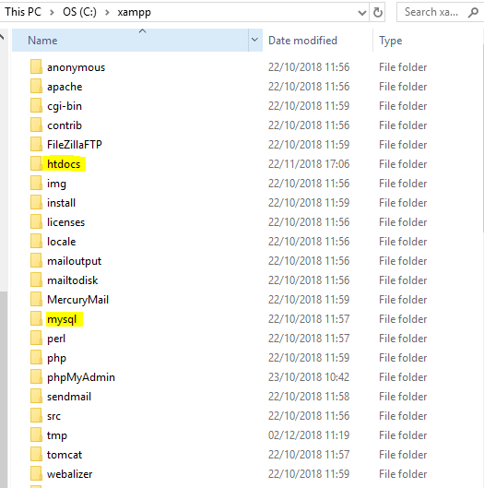

Assignment file stored in “htdocs” file.

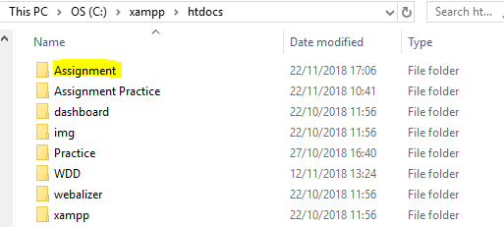

Xampp control panel to run Apache and MySQL

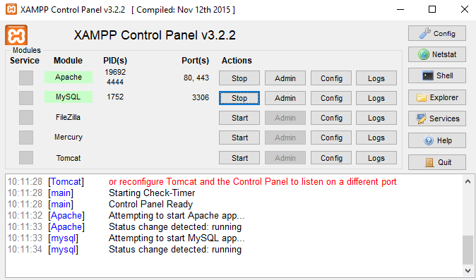

Run web application in browser using [http://localhost/Assignment/web dev group assignment/code/](http://localhost/Assignment/web%20dev%20group%20assignment/code/)

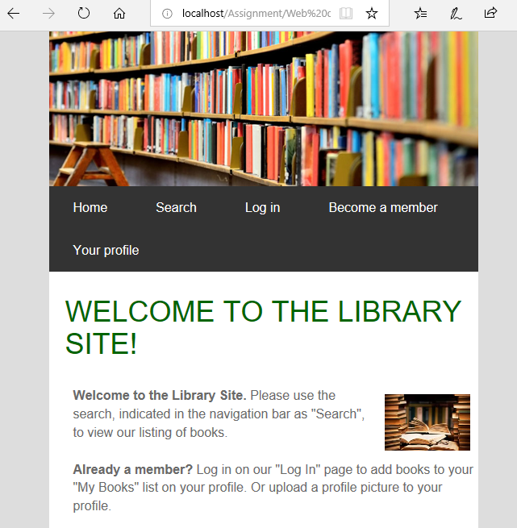

Create database “mydb” at <http://localhost/phpmyadmin>

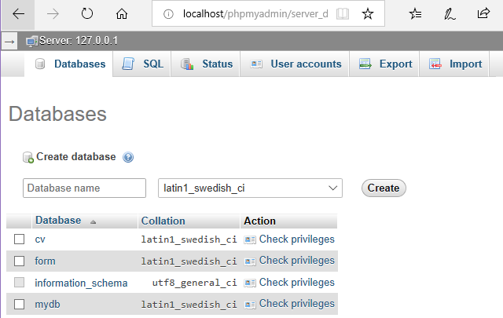

Create three tables for web application

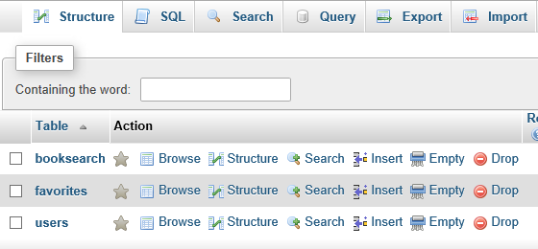

Copy and paste create table SQL statement to create table structure

